Data Exploration: Simple Diffusion Tutorial

# Upload past student data

To synthesize student usage in the past, execute the IPython (Jupyter) Notebook “-Tutorial-Setup”:  


# Explore Student Diffusion Data by Alloy Name

1: From the MDCS homepage, click on “Data Exploration” then click on “Search by Keyword”:   
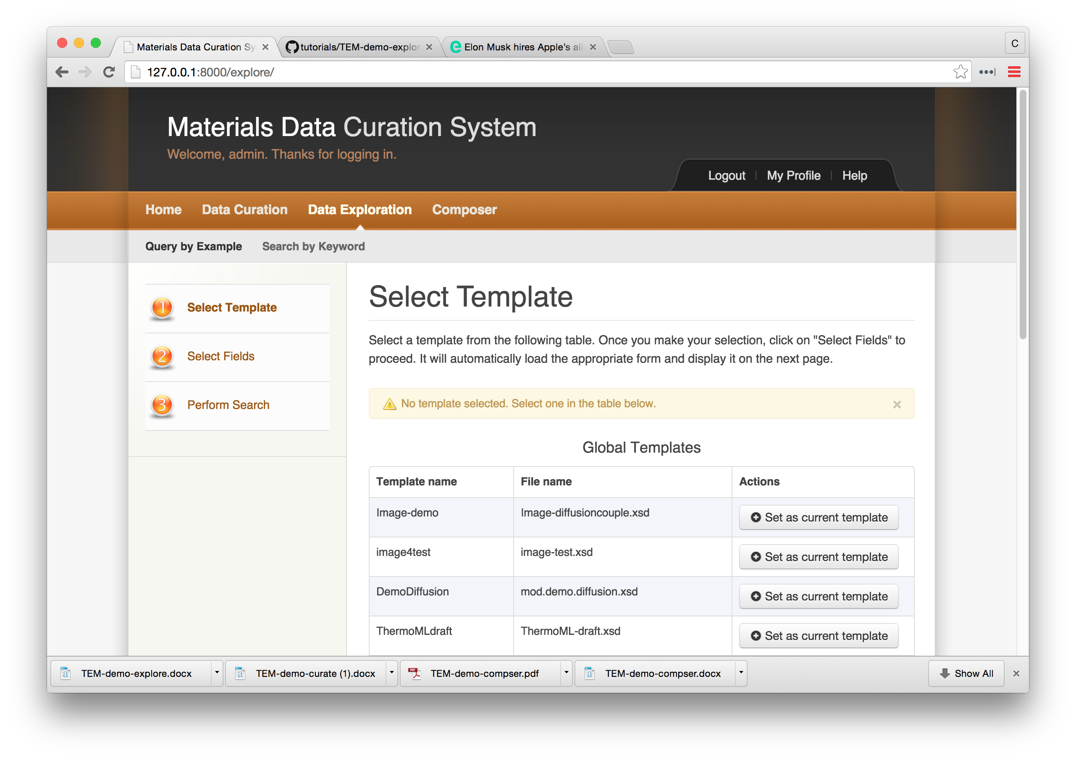

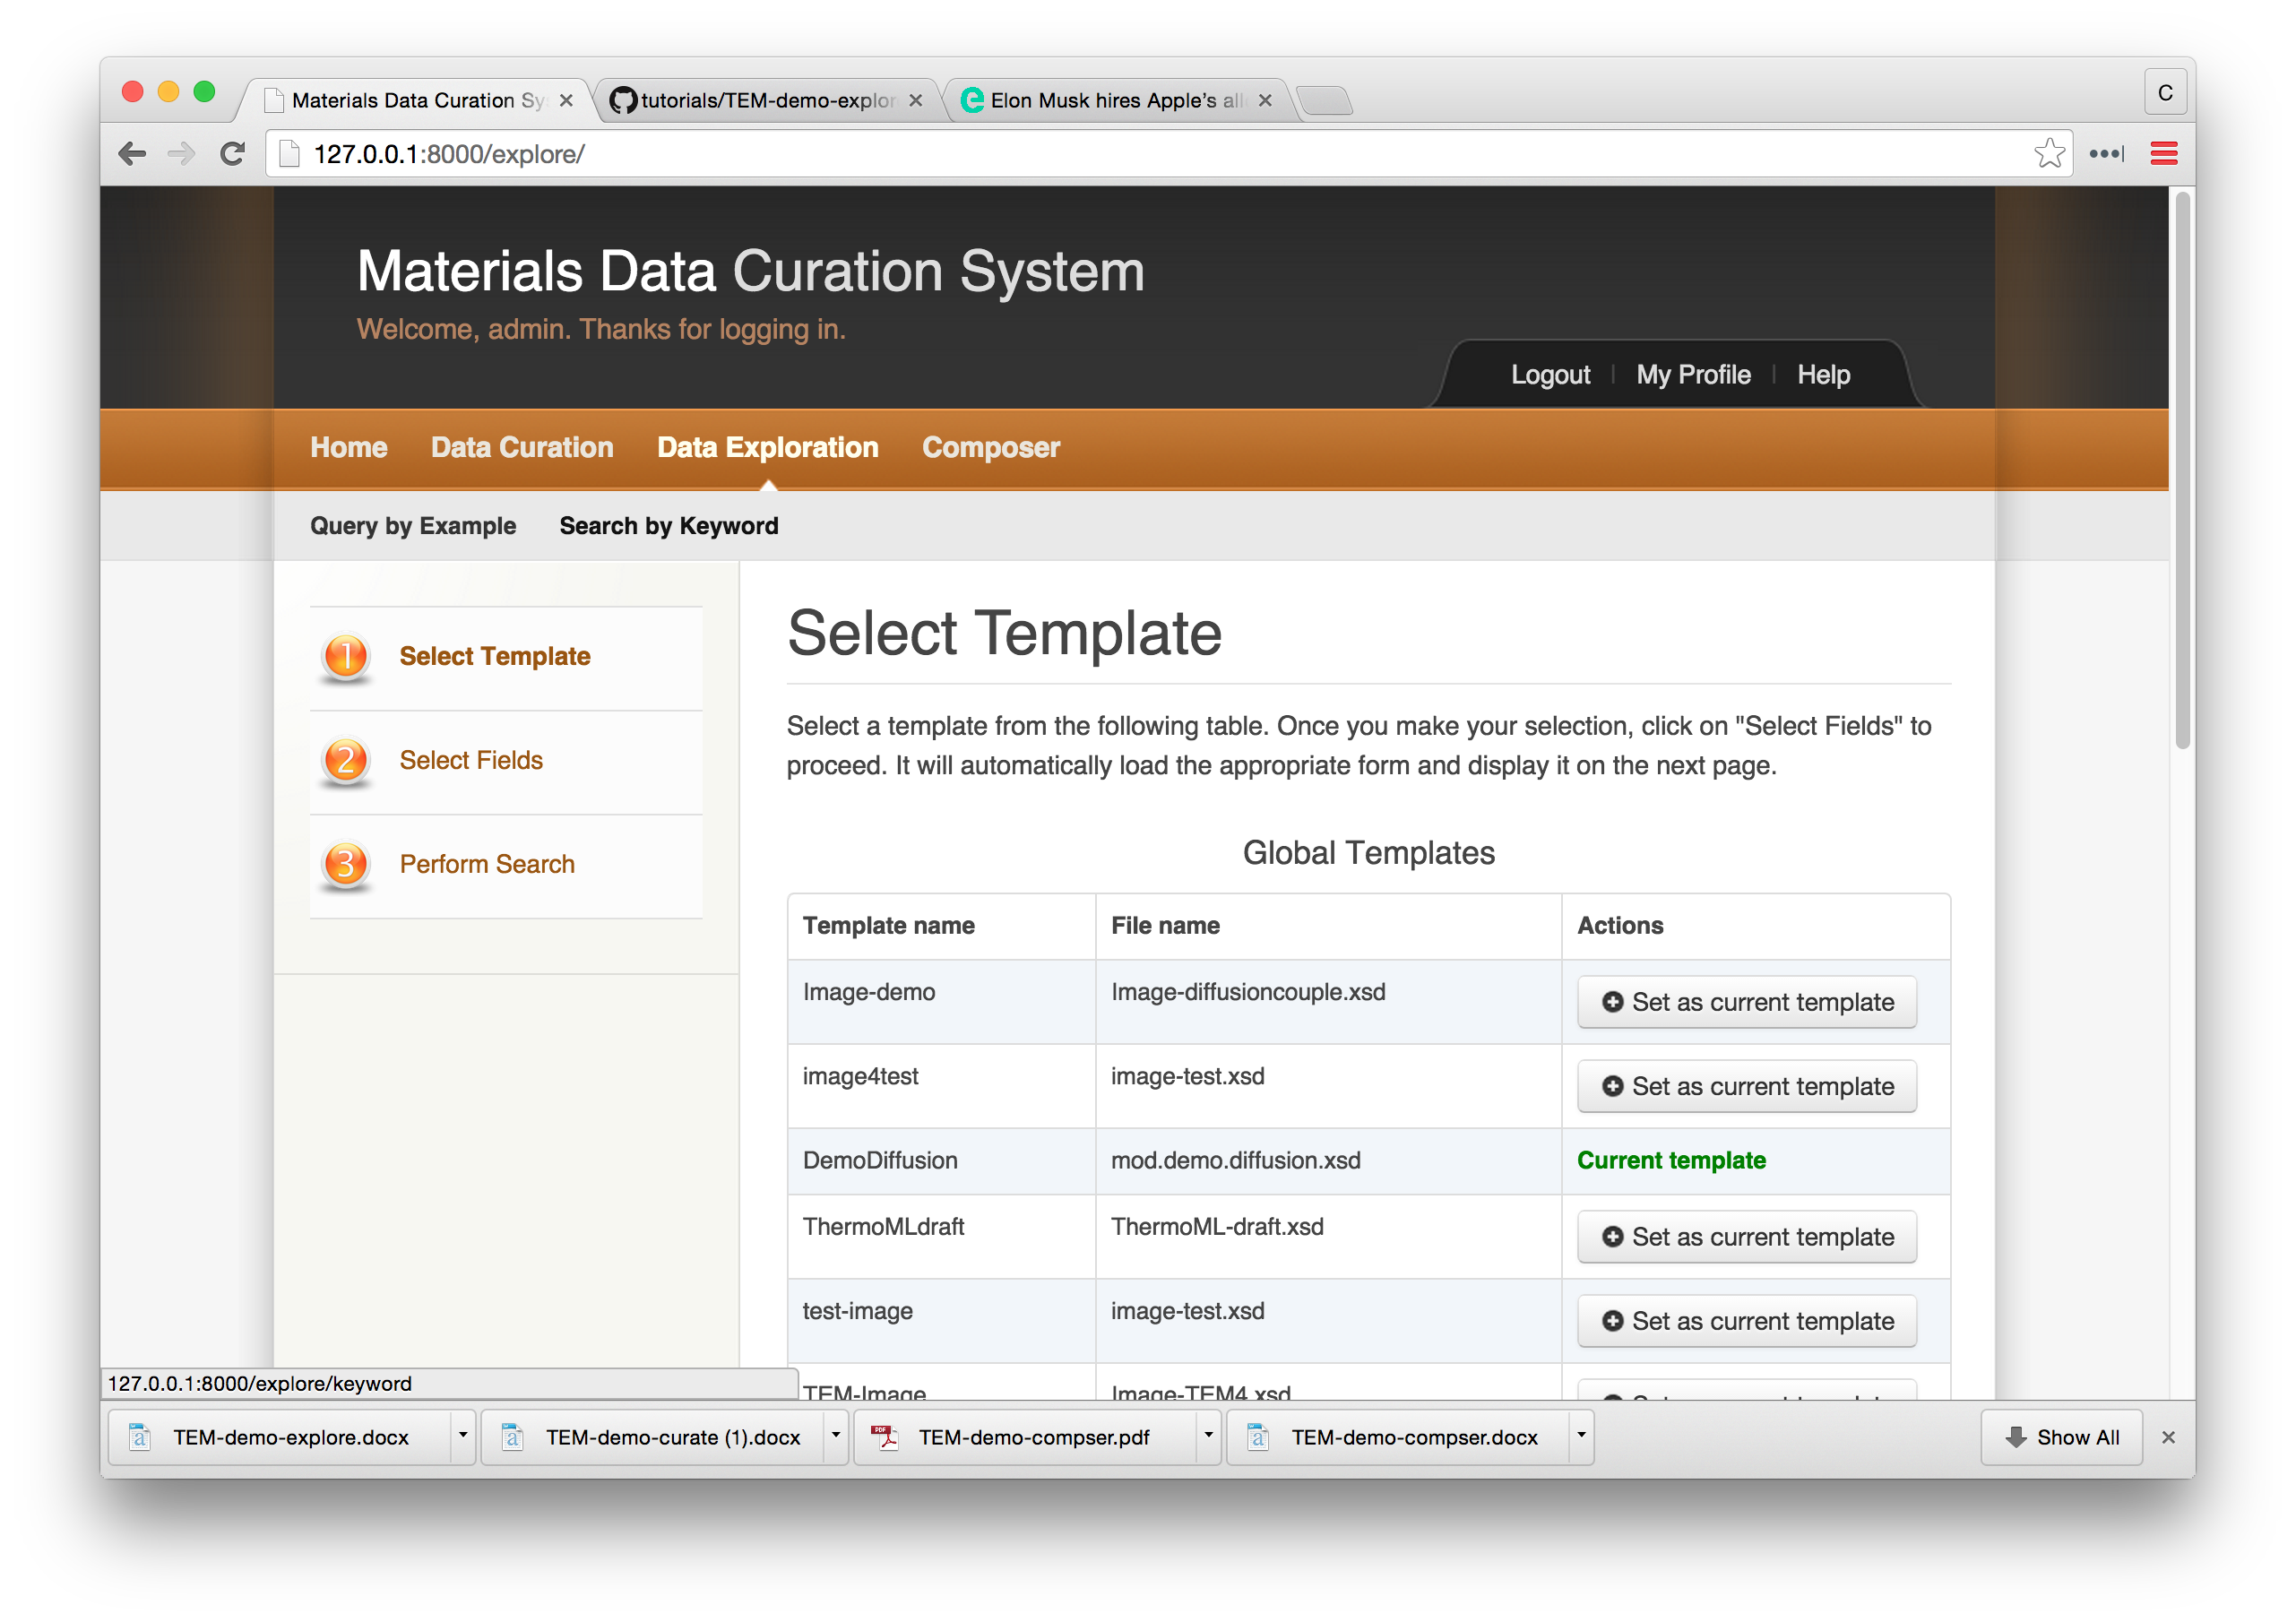

2: Search for all records containing the “IN100” alloy

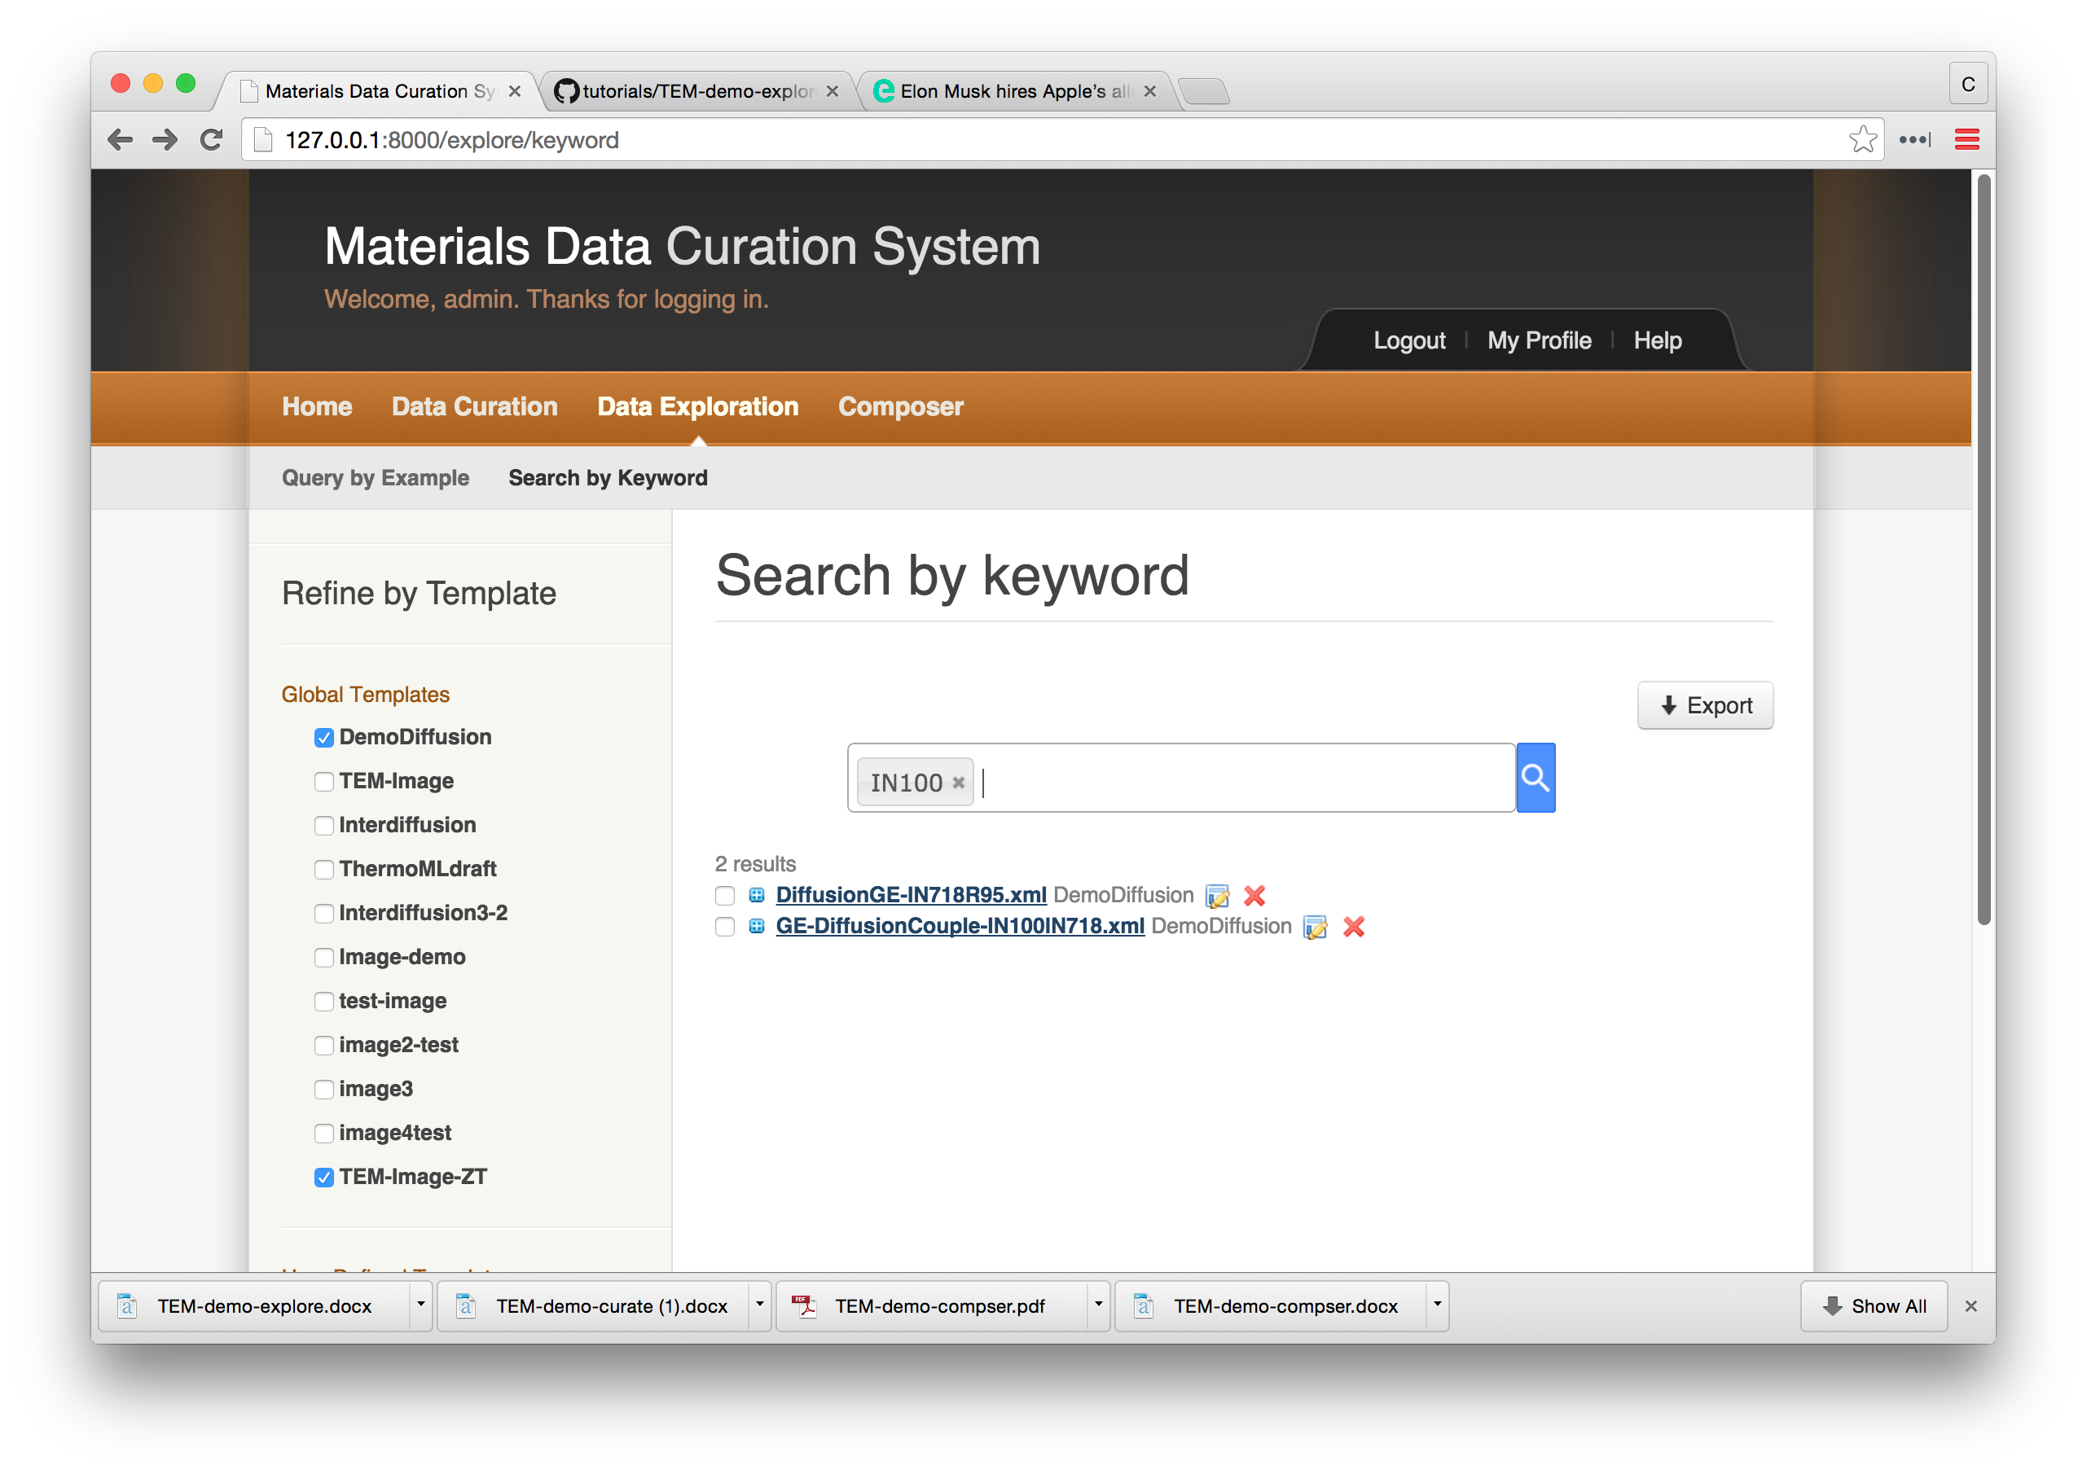

Select “GE-DiffusionCouple-IN100IN718” to expand the view.

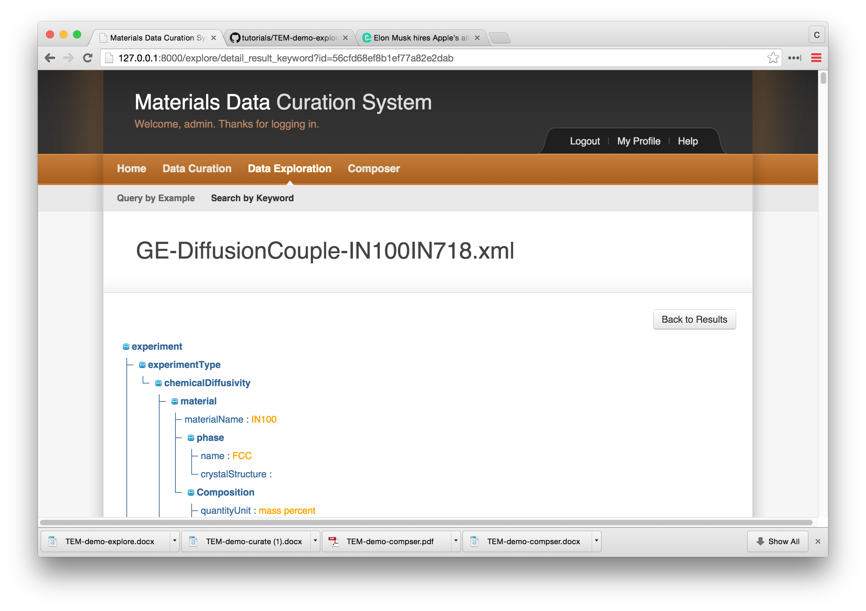

Scroll down to the bottom of the screen to find the link to the attached micrograph. In a new browser tab, enter the link and the micrograph will download.

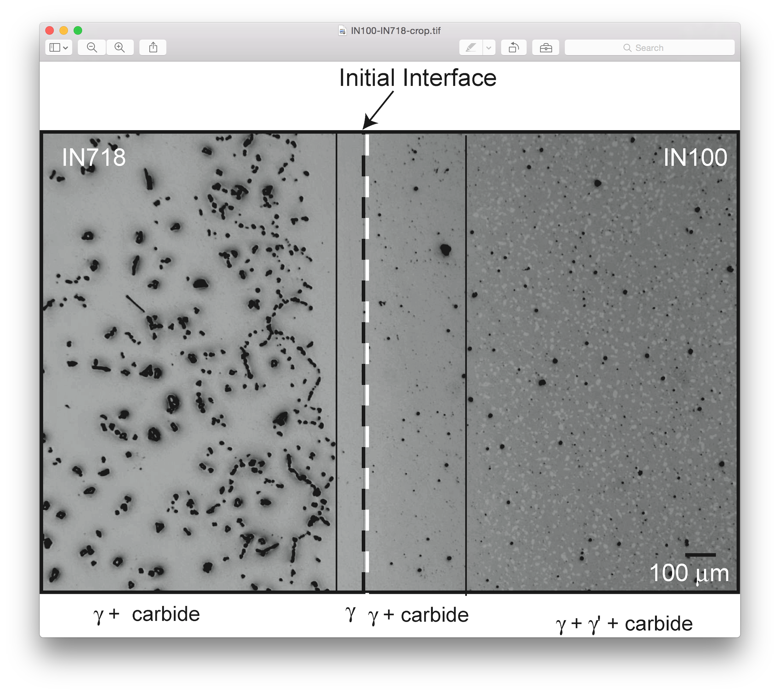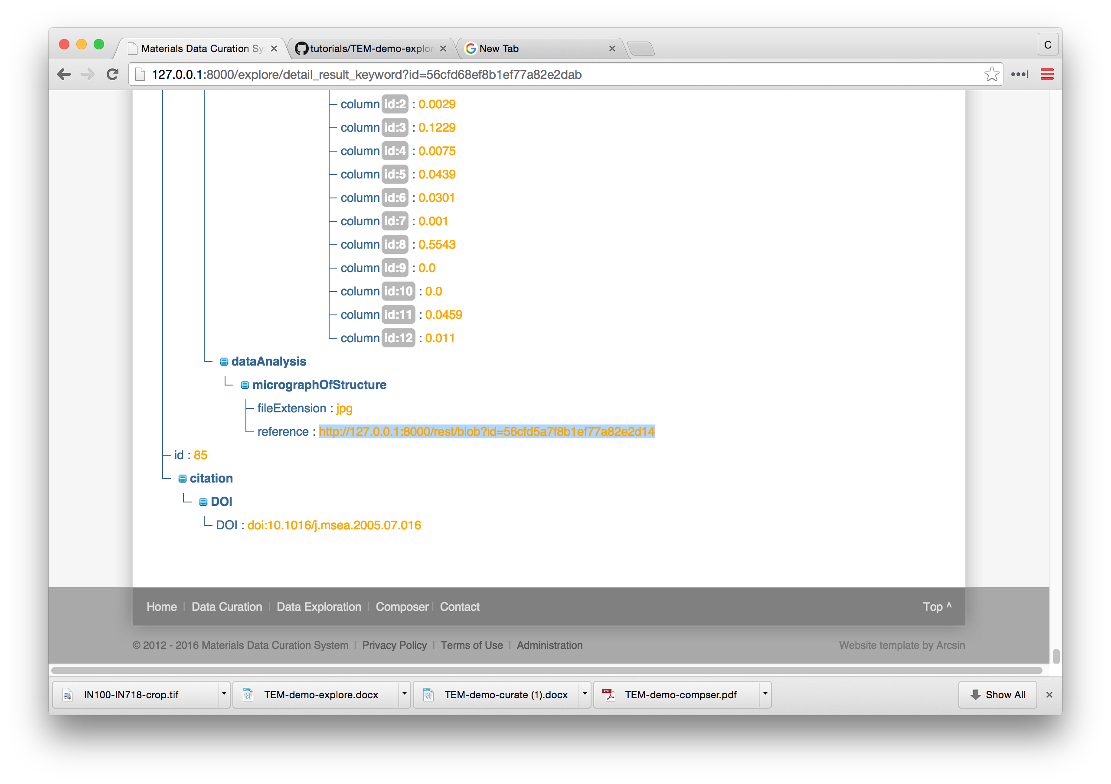

Now if one wants to export the composition profiles, return the “Results”. Scroll back to the top of the page.

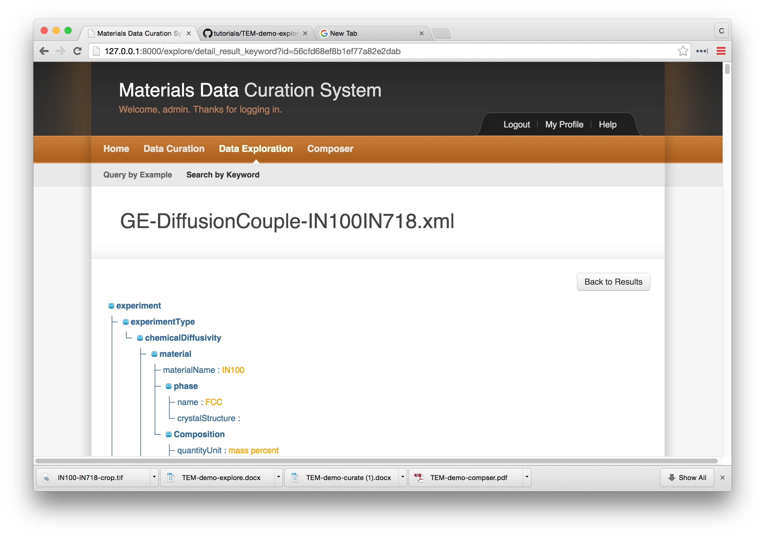

Select both data sets to export and click on “Export”

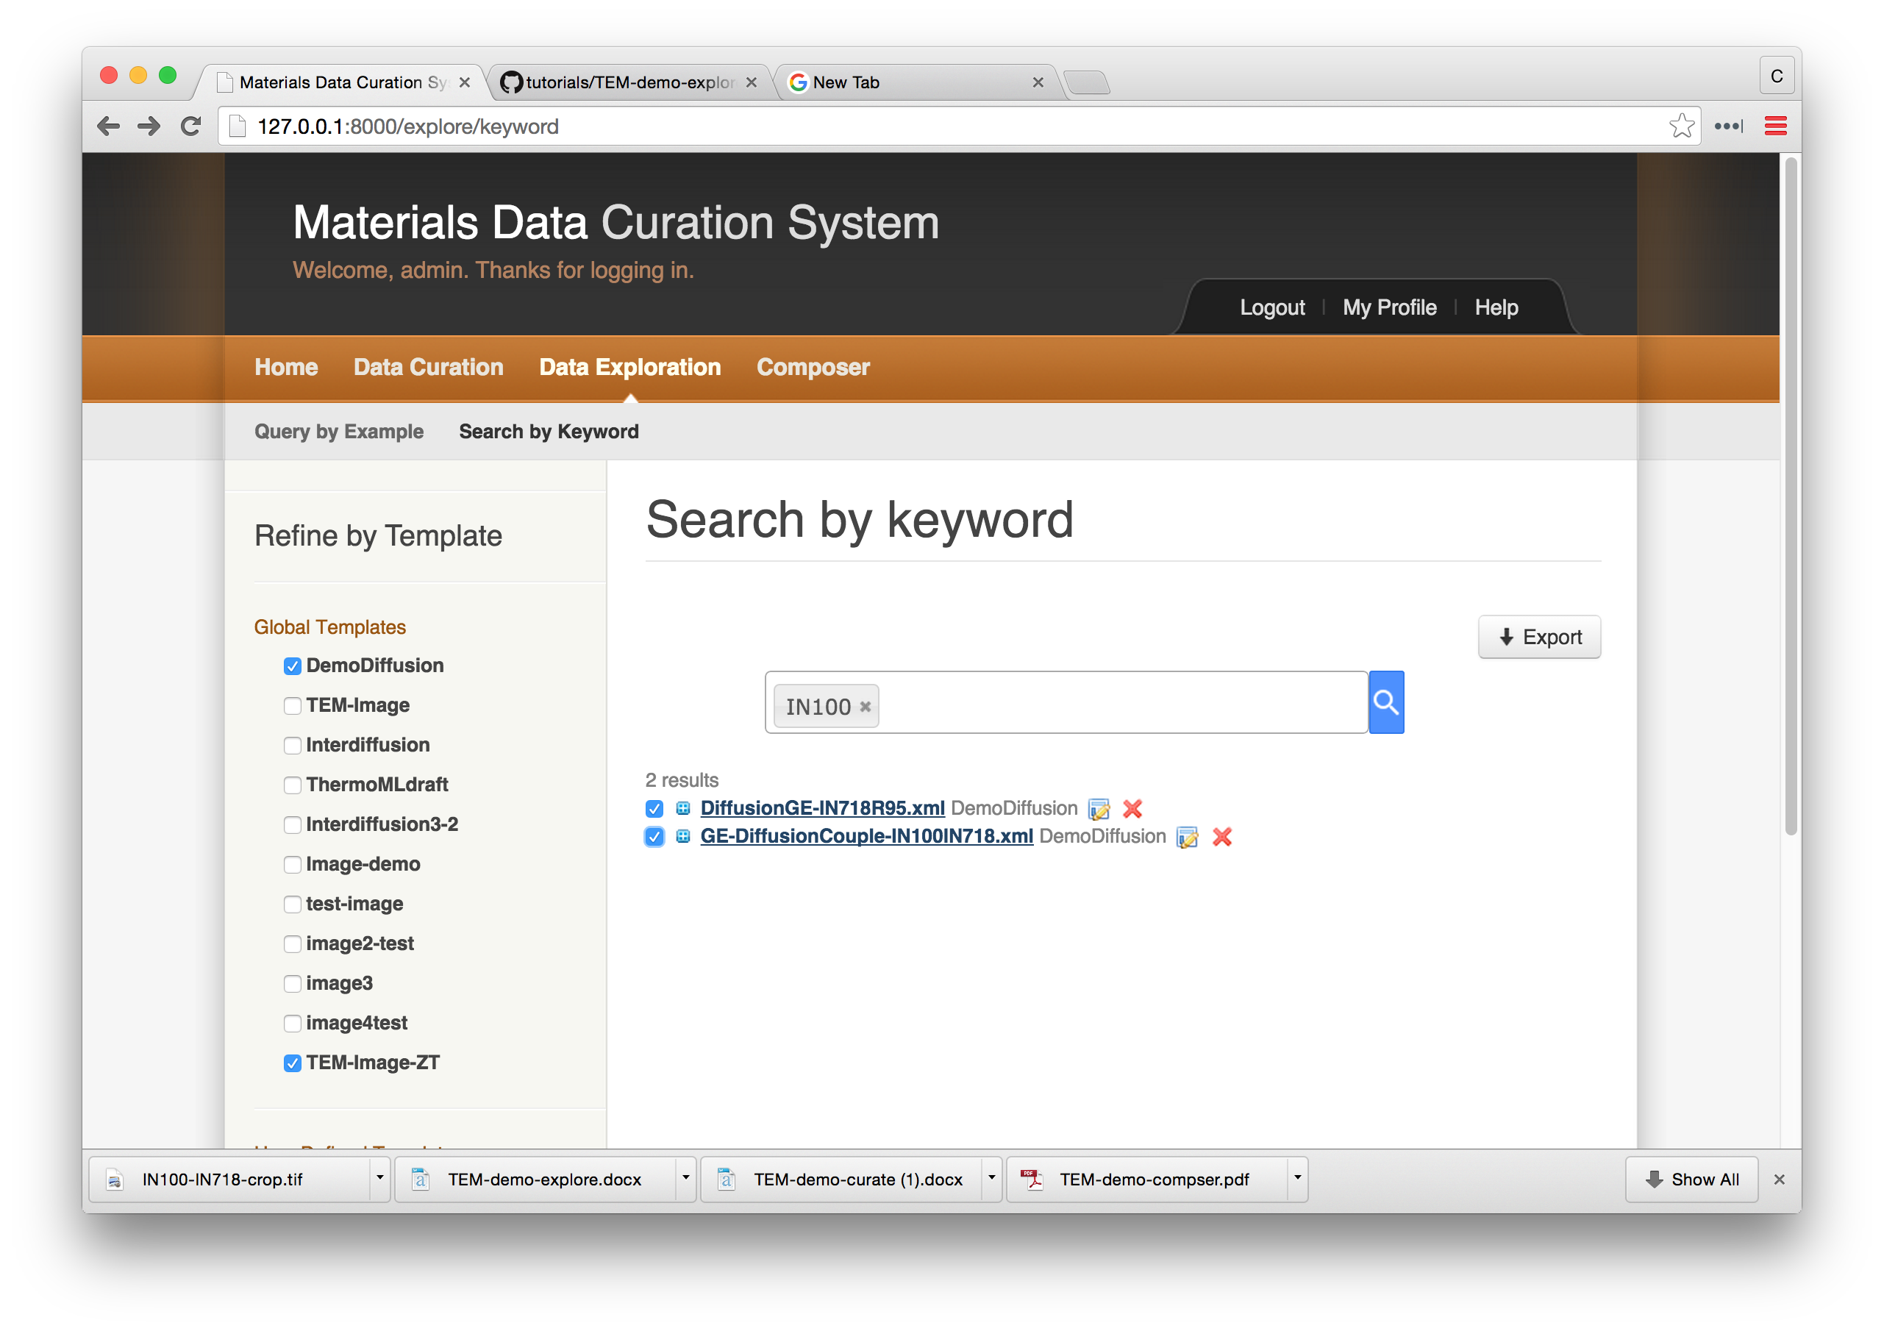

Chose to export the files as a “CSV” files.

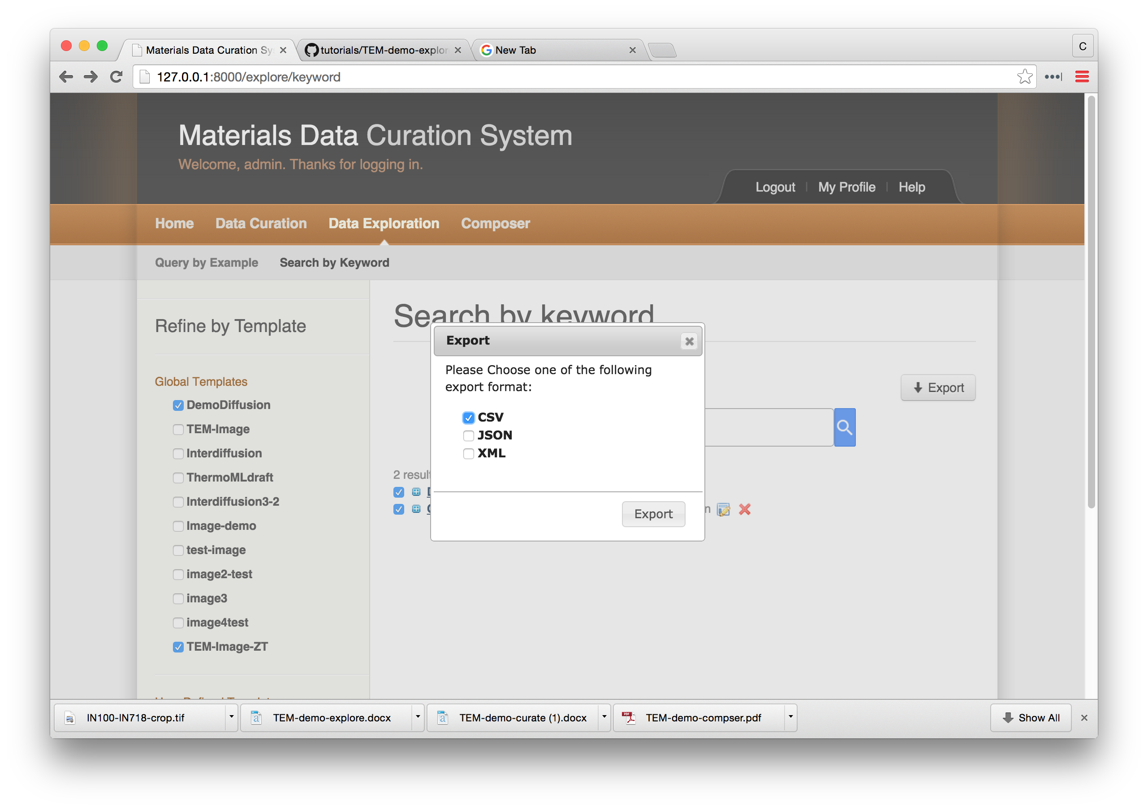

The files will then download and appear in folder labelled CSV.

